Measuring GRAVITATIONAL POTENTIAL ENERGY
TASK: Measure the GPE object and how well it converts to Kinetic energy
A very simple science report has been already started for you – see below. You need to complete the report. While this task is simple, the skills you develop will be useful in later experiments. The parts you need to do are…
- make up a suitable method (see the results table for clues)
- Collect results neatly and calculate GPE and Kinetic energy
- Graph the dependant variables against the independent variable.
Aim: To measure how GPE and kinetic energy are connected.
Variables: Independent (2) = Height of the object
Dependant = Gravitational Potential Energy of the object
Controlled = _______________________________________________
Hypothesis: The higher the object, and the GPE it has, and the greater the Kinetic Energy it will have at the bottom of the ramp. This is because GPE is converted to KE as the ball rolls down the ramp.
Method: MATERIALS

- Large marble or tennis ball
- Ruler
- Stopwatch
- Metre ruler
- Electronic balance

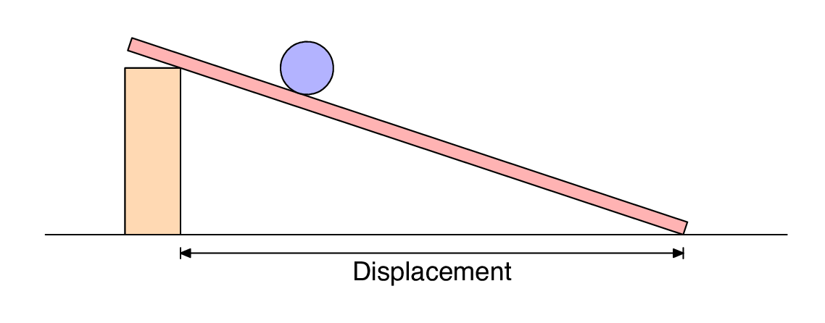
2 m
ht
METHOD:
- __________________________________________________________________
- __________________________________________________________________
- __________________________________________________________________
- __________________________________________________________________
- __________________________________________________________________
- __________________________________________________________________
- __________________________________________________________________
Results:
Table1: E_{GP} of a rolling object.
Object Height, h (in m) | Uncertainty in the Height (in m) ± | Mass, m  (in kg) | Uncertainty in the mass (in kg)  ± | E_{GP} (J)  $$GPE=m×9.8×h$$
0.10 | 0.005 | 0.0458 | 0.0000005 | 0.045
0.12 | 0.005 | 0.0458 | 0.0000005 | 0.054
0.14 | 0.005 | 0.0458 | 0.0000005 | 0.063
0.16 | 0.005 | 0.0458 | 0.0000005 | 0.072
0.18 | 0.005 | 0.0458 | 0.0000005 | 0.081

Table1: E_{K} of a rolling object.
Mass, m (in kg) | Uncertainty in the mass (in kg)  ± | Time to roll 2.0 m (seconds) |  |  |  | Uncertainty in the Avg time (in s)  ± $\frac{range}{2}$ | Velocity, v (m/s)  v = 2 / time | Kinetic Energy E_{K} (J)  KE = ½ x m x v²
 |  | Trial 1 | Trial 2 | Trial 3 | Avg
0.0458 | 0.0000005 | 2.00 | 1.97 | 1.97 | 1.98 | 0.015 | 1.01 | 0.023
0.0458 | 0.0000005 | 1.88 | 1.84 | 1.78 | 1.83 | 0.05 | 1.09 | 0.027
0.0458 | 0.0000005 | 1.71 | 1.62 | 1.66 | 1.66 | 0.045 | 1.20 | 0.033
0.0458 | 0.0000005 | 1.53 | 1.47 | 1.50 | 1.50 | 0.03 | 1.33 | 0.041
0.0458 | 0.0000005 | 1.37 | 1.28 | 1.31 | 1.32 | 0.045 | 1.52 | 0.053

Table2: Comparision of E_{GP} and E_{K} for a ball rolling down a ramp.
Calculate the efficiency of the ramp by comparing the E_{GP} and E_{K} using the table below.
E_{GP} (J)  From the table, write the E_{GP} in here again | Kinetic Energy, E_{K} (J)  From the table, write the E_{K}’s in here again | Efficiency (%)  $$Efficiency= \frac{E_{K}}{E_{GP}}×100$$ | Average Efficiency of the ramp (%)
0.045 | 0.023 | 52 | 55
0.054 | 0.027 | 51
0.063 | 0.033 | 53
0.072 | 0.041 | 57
0.081 | 0.053 | 65

Graph1: E_{K} versus the E_{GP}
E_{K} - Kinetic Energy (Joules) ((Joules(Joules)
E_{GP} – Gravitational Potential Energy (Joules)
.

Identify the trends, Patterns, Relationships
The average efficiency of conversion from the E_{GP} to E_{k} was 55%. This means not all of the E_{GP} was converted into E_{k} and an average of 45% of the E_{GP} was converted into a type of energy not measured in this experiment. This energy was likely used to overcome friction with the ramp and friction with the air as the ball rolled. The results suggest that nearly half (45%) of the energy initially in the ball was used to overcome friction and not converted into kinetic energy.
As the Gravitational Potential Energy (E_{GP}) increased, the Kinetic Energy (E_{K}) of the ball increased. For example, at a height of 0.1 metres the ball had a E_{GP} of 0.045 joules. When the ball rolled down the ramp this was converted into 0.023 joules of E_{k}. At the highest height of 0.18 metres the ball had a E_{GP} of 0.081 joules, which was converted into 0.053 joules of E_{k} when the ball rolled down the ramp. The ball gained more E_{K} (moving energy) when it was higher and started with more E_{GP} (stored energy).
The relationship was not linear and is best described by the second order polynomial shown below.
$$E_{k}=16{E_{GP}}^{2} -1.2E_{GP} +0.04$$
The relationship above shows that the higher the ball on the ramp, the more E_{GP} is actually converted into E_{K}. The efficiency was highest (65%) at the greatest height, and generally lowest at the lowest heights.

Identify the Uncertainty and Limitations
There is only a small amount of uncertainty in the data. The uncertainty in measuring the mass of the ball was very small (<0.01%). The uncertainty in the times was highest in the lowest time (1.32±0.045 seconds, 3.4%), but still relatively low. The uncertainty in the heights was highest in the lowest height (0.10±0.005 metres, 5%), but also still relatively low. These low uncertainty values suggest that the data is relatively certain.
The trend formed by the data is also relatively certain. The data makes a consistent pattern and is very well described by a second order polynomial, with an R² value (0.09988) very close to one.
The data appears limited in two main ways. There was no real attempt to reduce the friction affecting the ball and therefore a significant amount of E_{GP} was not converted to E_{K}. In a high school lab this is unavoidable, but does make it hard to relate the results to other real-life scenarios. The other limitation was the lack of a large range in the heights of the ball. The ball was rolled from a height of 10 cm to 18 cm, which is a small range. Even though the identified trend appears relatively certain, it is limited in the range of heights it can be accurately applied to.

Conclusions
This investigation showed that a significant proportion of the E_{GP} was not converted into E_{K}. A ball rolling down a ramp was not particularly efficient. Close to half the E_{GP} was “wasted” by conversion into energy needed to overcome friction with the surface and air. Considering the simplicity of the experiment, any device with many moving parts would be expected to have only a low efficiency, with most of the energy put into the system being used to overcome friction between surfaces. Generally speaking the more complicated a machine, the less efficient it should be.
This investigation showed that the efficiency increased as the height of the ball increased, meaning more of the E_{GP} was converted to E_{K} at greater heights. This was not expected as it was assumed that the increase in friction with the air would cause greater energy loss (and therefore lower efficiency) when the ball was moving faster. The results of this investigation may show that machines which operate at higher speeds actually provide a more efficient conversion of energy than machines which operate at lower speeds.

Evaluating Reliability and Validity
The investigation produced reliable results. There was low uncertainty in the data, and no anomalies recorded. The trend identified in the data also had low uncertainty. It is likely that other students would produce similar data.
The relationship identified is not particularly valid. The amount of friction of the ball was not controlled, which means that it may have varied for the different trials. This issue did not appear to create uncertainty within the trials, but would have caused the variation in efficiency when the ball was rolled from different heights. It is not known which type of friction (with the surface or friction with the air) caused the efficiency to change. Thus, it is hard to make predictions as the source of inefficiency is difficult to identify. The relationship may also not be valid outside the small range of heights used in the investigation.

Improvement and Extensions
There are several ways the methodology could be improved. The greatest improvement would be trying to control the effect of friction on the ball as it moves. As friction was not controlled it would have varied for each of the heights used for the ball. This is shown in the results in the way that efficiency varied at different heights. There is one improvement which may control the amount of friction. This would be to place the ball at the same position on the ramp (so it rolls exactly the same distance each time), and vary the height by varying the angle of the ramp. This would control the amount of friction from the ball rolling across the surface. The amount of friction caused by the ball moving through air (“air resistance”) would be very difficult to control in a regular high school laboratory.
Although the experiment had low uncertainty, having a higher number of trials would help reduce the uncertainty even further.
An extension of this investigation would be to use different objects and surfaces for the experiment. An example of this could be simply dropping the ball, and not using a ramp at all. This would mean there was no rolling friction present in the investigation.

